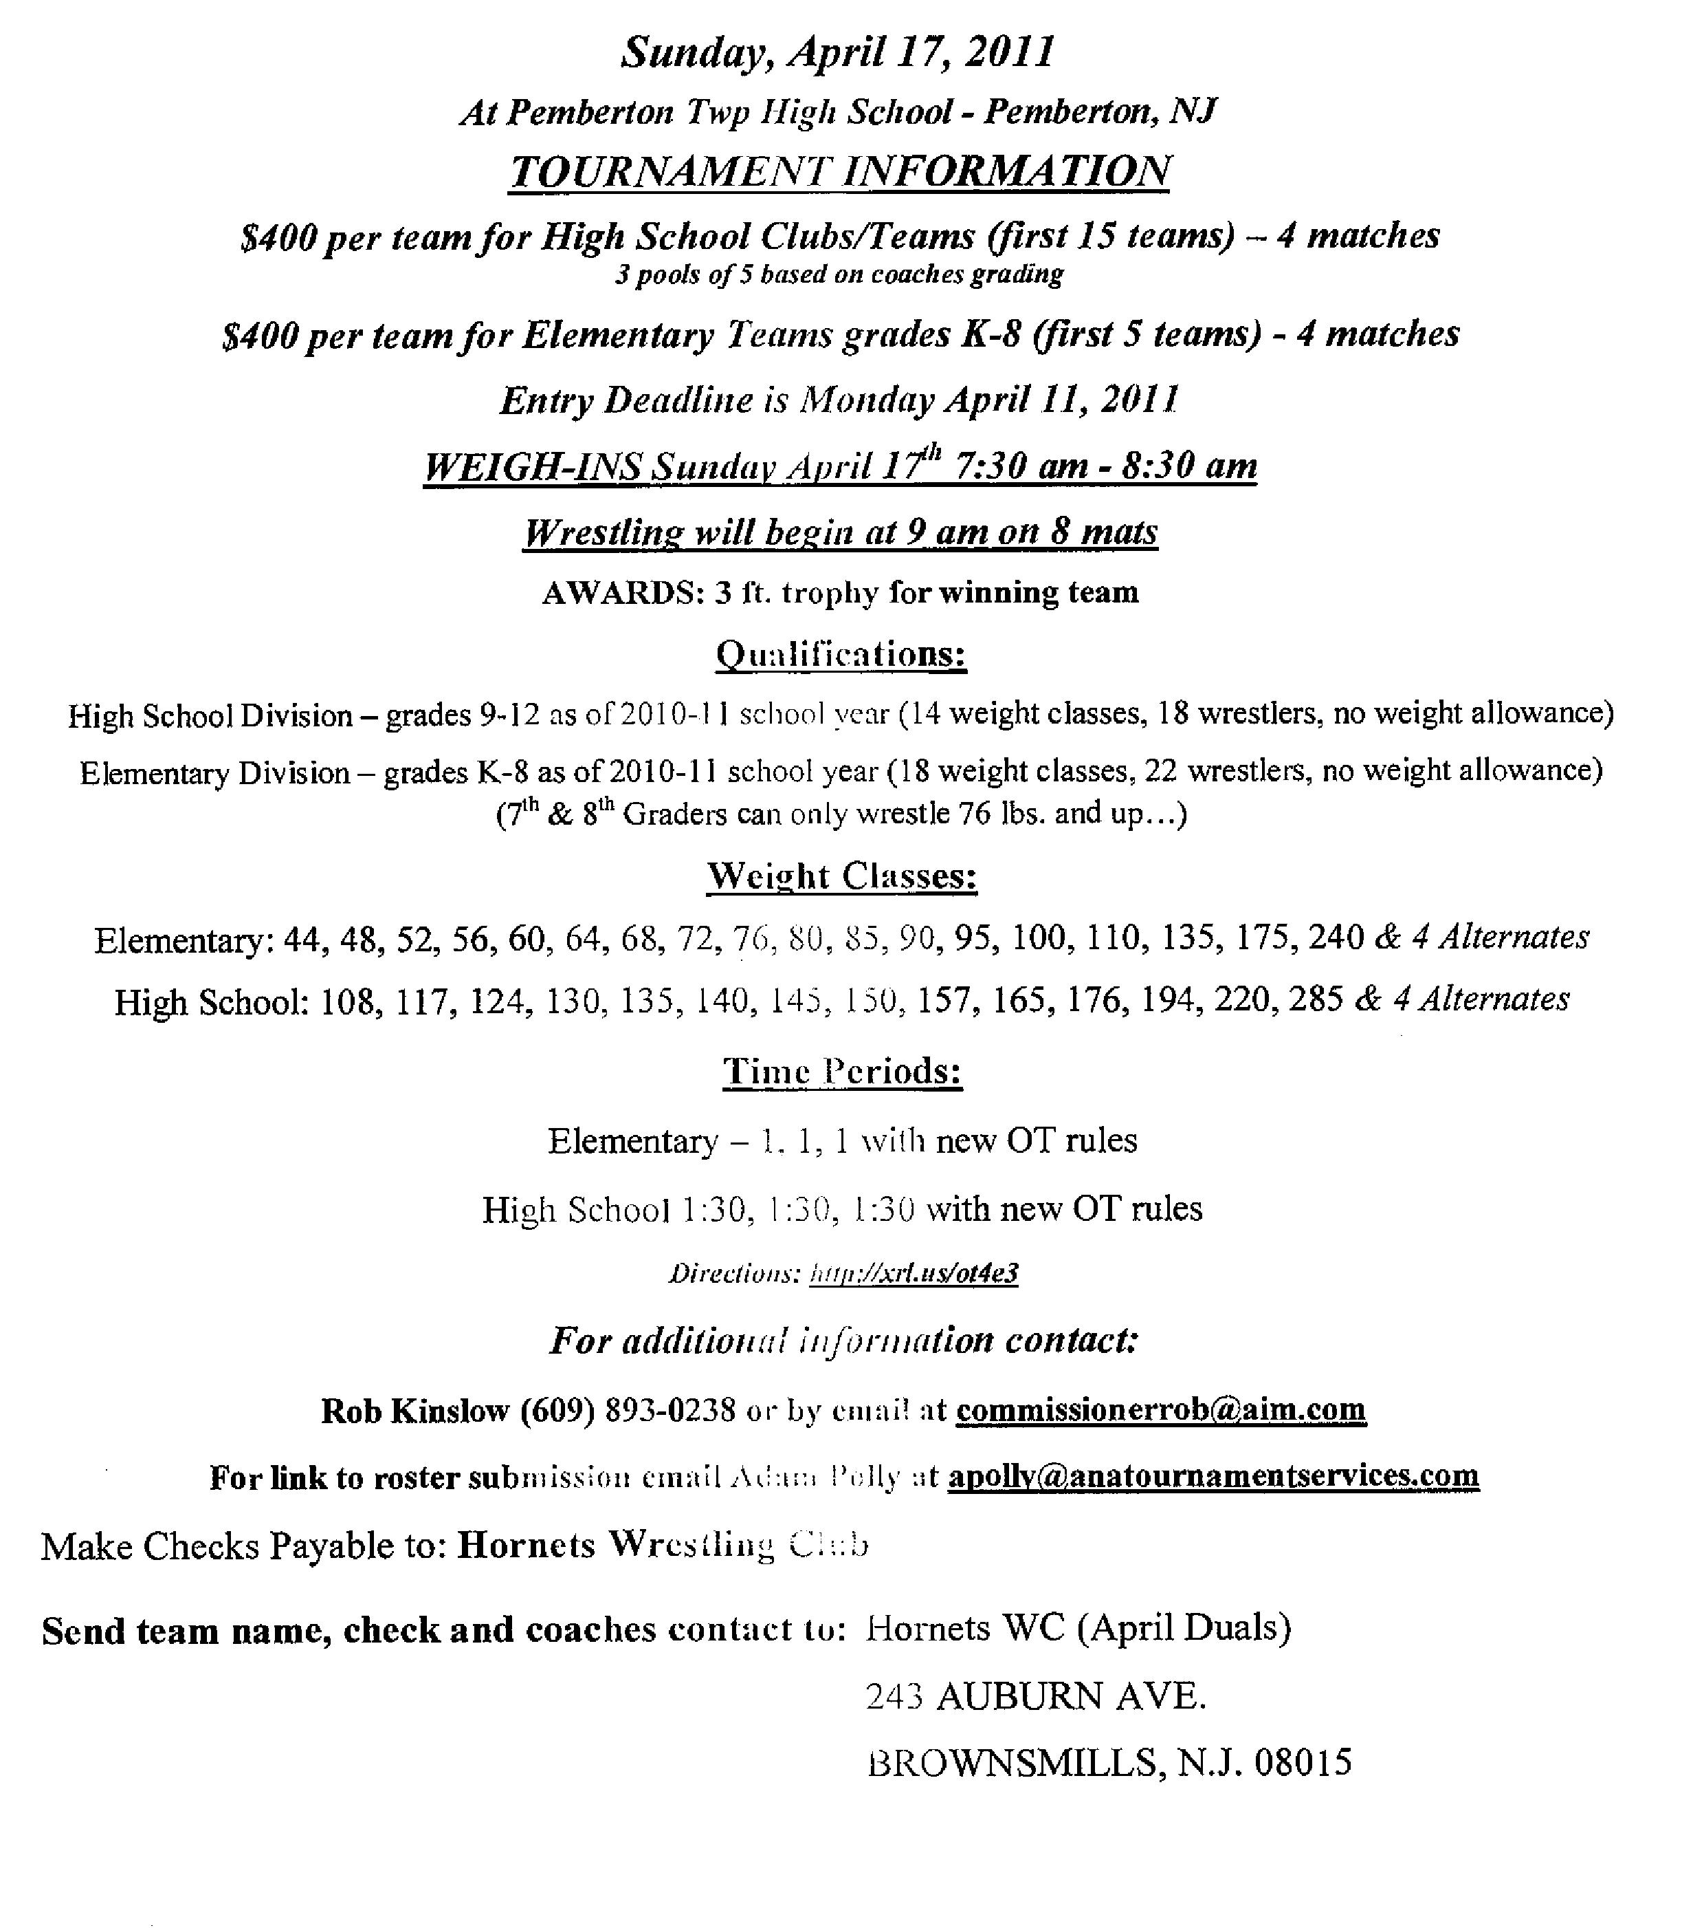
(May Duals)

Award 5 ft. trophy for winning team
Entry Deadline May 14, 2012

WEIGH INS Sunday May 20, 2012 6:30 thru 7:30 AM
Wrestling will begin at 8 AM on 8 mats
Sunday, May 20, 2012

